**AWS – Create EC2 via CLI**

In this lab, students will use the AWS CLI to create an EC2 instance.

**Create a new user account with CLI Programmatic access**.

1. Login the AWS console as Administrator. Make sure you’re in the **N. Virginia** region.
2. Go to **IAM**
3. Click **User group** on the left panel
4. Click the **Create group** button
5. Make the User group name ***CLI-Access***.
6. Scroll down to Attach permission policies. In the search box, type **ec2full** and hit **Enter**. Check the box next to the *AmazonEC2FullAccess* policy.  
   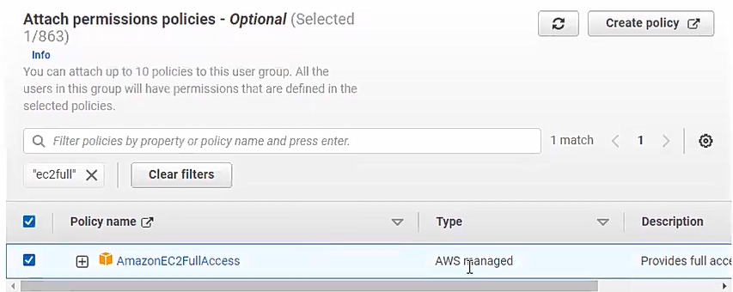
7. Click the **Create group** button. You should see the new group in the inventory.  
   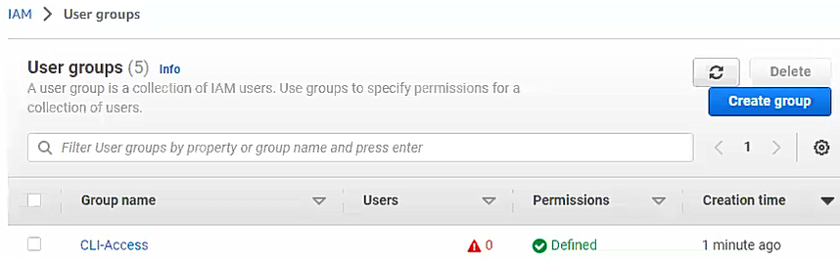
8. On the left panel, click **Users**.
9. Click the **Add users** button.
10. For the User name, type ***yourlastname-cliuser***.
11. Check the *Provide user access to the AWS Management Console* box and *I want to create an IAM user*.  
    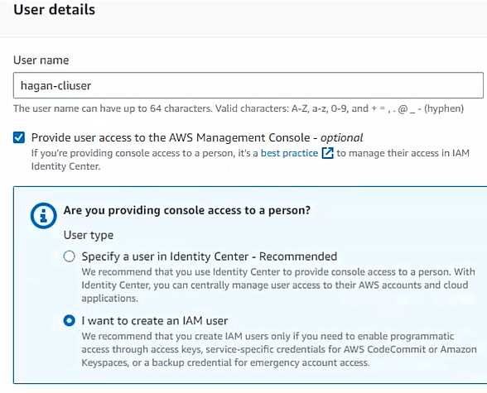
12. Select *Customer password* and enter a password you can remember. **Uncheck** *Users must create a new password at next sign-in – Recommended*.  
    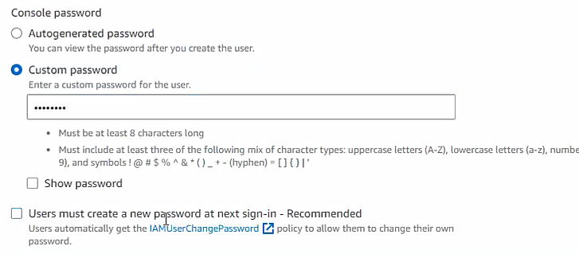
13. Click **Next**.
14. On the Set permission page, check the box next to the **CLI-Access** group.  
    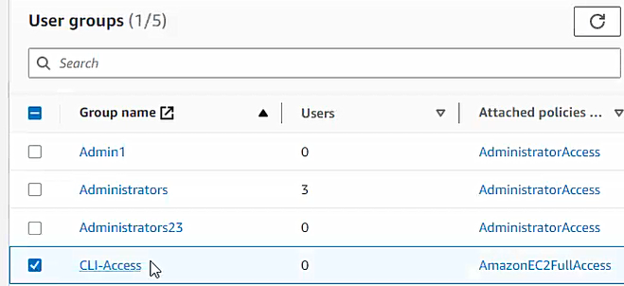
15. Click **Next**.
16. On the *Review and create* page, click **Create user**.
17. Click the **Download .csv file** button and save it to your local drive.
18. In the Users inventory, click your newly create cli user.
19. Click on the *Security credentials* tab and under *Access keys*, click the **Create Access keys** button.
20. Under *Use case*, select **Command Line Interface (CLI)**
21. Scroll down and check the **checkbox** *I understand the above recommendations and I want to proceed to create an access key.*
22. Click **Next**
23. Under *Description tag value* type in **EC2-CLI-Access** and click the **Create access key** button.
24. Open Notepad (or any Text Editor)
25. In the AWS console (*Retrieve access keys*), click the copy icon(s) (one at a time) to copy the **Access key** and **Secret access key** (hit *SHOW* first) and paste in the Text Editor. You may want to label each value in your Editor.  
     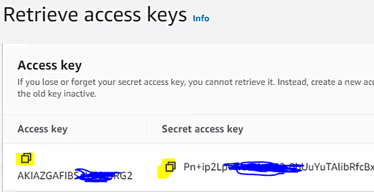  
      
    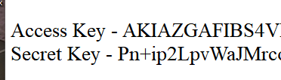
26. Click the **Done** button.

**Download and install AWS CLI console (Do Not Perform)**

1. To install on a Windows PC, download and run the AWS CLI MSI installer for Windows (64-bit): <https://awscli.amazonaws.com/AWSCLIV2.msi>
2. To confirm the installation, open the **Start** menu, search for cmd to open a command prompt window, and at the command prompt use the **aws --version** command. Go to Step 6.  
     
   If Windows is unable to find the program, you might need to close and reopen the command prompt window to refresh the path.
3. To install on a Mac, download the macOS pkg file: <https://awscli.amazonaws.com/AWSCLIV2.pkg>
4. Run your downloaded file and follow the on-screen instructions.
5. To verify that the shell can find and run the aws command in your $PATH, use the following commands:  
   $ **which aws**   
   /usr/local/bin/aws   
   $ **aws --version**   
   aws-cli/2.10.0 Python/3.11.2 Darwin/18.7.0 botocore/2.4.5  
     
   If the **aws** command cannot be found, you might need to restart your terminal

**Preparing to use AWS CloudShell to create EC2 Instance**

1. To access the AWS CLI (CloudShell), type CloudShell in the AWS Mgmt Console search box.
2. To create an EC2 Instance from the AWS CLI we need to the following command in the AWS CLI (CloudShell):  
   **aws ec2 run-instances** --image-id ami-xxxxxxxx --count 1 --instance-type t2.micro --key-name MyKeyPair --security-group-ids sg-903004f8 --subnet-id subnet-6e7f829e  
     
   Copy/paste the above command in your Text Editor you opened earlier for your user access keys. You will replace the information in red with your environment information.
3. To get the ami-xxxxxxx number, click on **EC2**. Under *Images*, click **AMI Catalog**.
   1. Check the **Free tier only** and **All Windows** checkboxes. Scroll down to the **Windows 2019 Base** image and highlight the associated ami-xxxxxxxxx number. Copy this value and replace the placeholder value in the **aws** command (Text Editor) with this value.  
      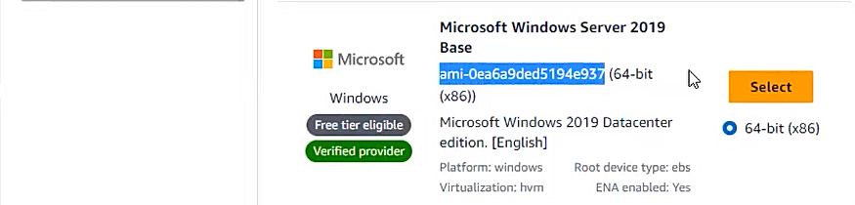  
      
4. To replace the MyKeyPair value in the **aws** command, in the left pane, scroll down to *Key pairs*.
   1. Create a new Key pair called ***yourlastname-WinCLI-key***. Make sure it’s it’s a .pem key. You can add the **Tag** *Key/Value* of *Name/yourlastname-WinCLI-key*.
   2. Click the **Create Key pair** button and save the file locally.
   3. Replace MyKeyPair value in the command with the name you your new key pair in the aws command (Text Editor).
5. To replace the Security groups ids value in the **aws** command, scroll down to **Security groups** in the AWS console.
   1. Click the **Create security group** button.
   2. Create a Security group called **yourlastname-WinCLI-sg** in your default VPC.
   3. Make sure to include and Inbound rule for **RDP** and Source from **Any IPV4** address.
   4. Once the Security group is created, copy the Security group ID an replace the Security groups ids placeholder.  
      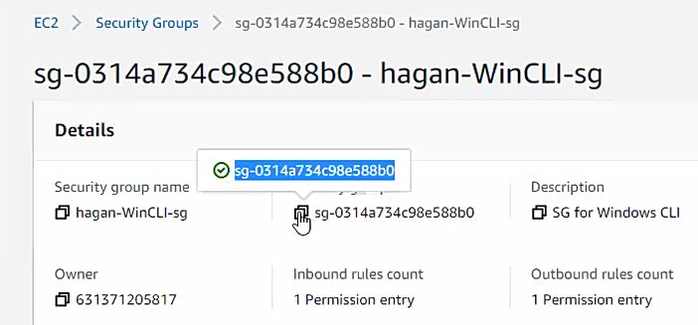
6. To replace the Subnet ids value in the **aws** command, select **VPC** in Services in the AWS console.
   1. Click **Subnets** in the left pane.
   2. Click any subnet from the *Subnet ID*.  
        
      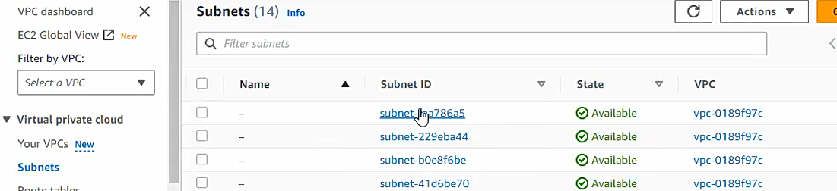
   3. Copy the Subnet ID and replace the subnet id placeholder in the **aws** command.
7. Your aws command is now ready to be executed in the AWS CloudShell.  
   

**Using AWS CloudShell to create EC2 Instance**

1. In the AWS Management Console, type CloudShell in the search box and click on CloudShell from the results. You should get a prompt once CloudShell has loaded.  
   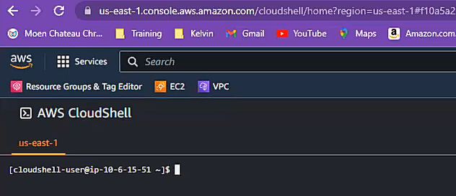
2. AT the prompt, type **aws –version** (that’s 2 dashes before version) to get the shell version.  
   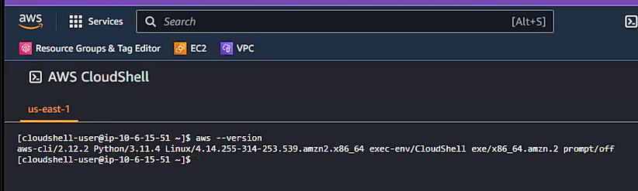
3. Clear the screen by typing **clear**.
4. In order to use the CLI, we must configure the CLI console with the user’s information (your newly created user) the commands will be executed for. In the CLI, type **aws configure** and hit **Enter**. Populate the subsequent prompts as follows:
   1. AWS Access Key: your access key you copied back in Step 25 of the first section
   2. AWS Secret Key: your secret key you copied back in Step 25 of the first section
   3. Default region name: **us-east-1**
   4. Default output format: **json**
5. To make sure these inputs registered correctly, type **aws configure** again and hit **Enter** with every prompt, not typing in any new information. (If you made a mistake, this is where you would make correction also)  
   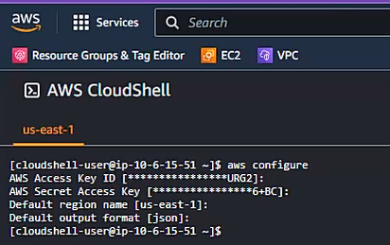
6. Clear the screen by typing **clear**.
7. Now copy/paste the aws ec2 run-instances command from your Editor into the CloudShell CLI and hit Enter. Make sure all your environment information is correct.  
   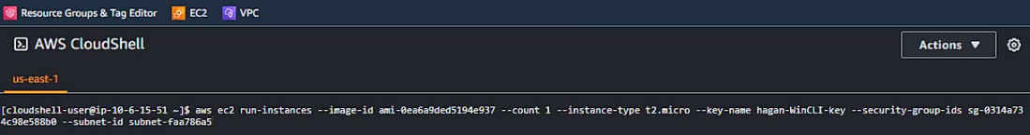
8. When the command executes, you will get a screen full of information and it will stop (there will be a colon : at the bottom of the screen). Scroll up slightly so you can see your command. Capture the screen and make sure the information circled in red is visible on your screenshot (that would be the command and InstanceID). Open a Doc and paste it under the heading **Screenshot1**.  
   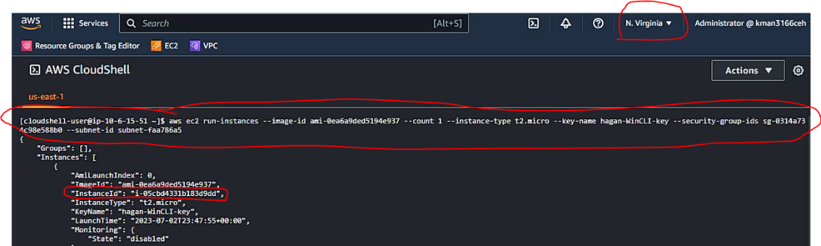
9. Hit either the **Space bar** or **Enter** to cycle through the rest of the output from the command.
10. Open another browser tab and go to your AWS Management console (if Management Console is not visible in another tab already).
11. Under the EC2 Instances inventory, make sure you newly created EC2 instance is running. Compare the InstanceID from the CLI with the InstanceID in the Management console. Once the Instance has passed the 2/2 health checks, capture the screen and make sure the information circled in red is visible on your screenshot. Paste it under the heading **Screenshot2 in the same Doc.**   
    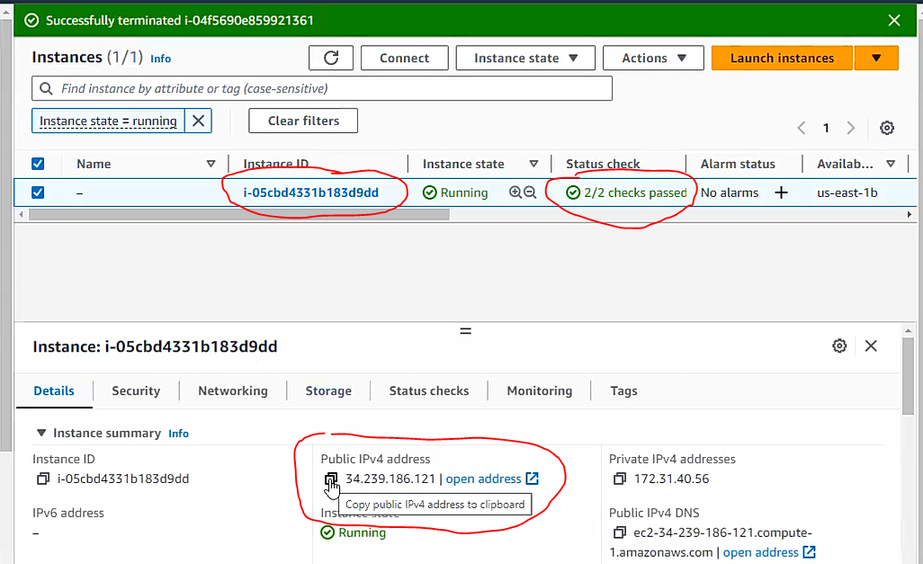
12. Copy the Public IPV4 address add paste it into your Text Editor.
13. As you have done in the previous lab where you created a Windows EC2 instance, retrieve the Administrator password and paste it into your Text Editor.
14. Open the Remote Desktop client (RDP), pasting in the Public IPV4 address. When prompted supply the Administrator username and its password from the Text Editor.
15. Align your AWS Management console and RDP as follows (you may need to shrink columns). Capture the screen and make sure the information circled in red is visible on your screenshot. Paste it under the heading **Screenshot3 in the same Doc.**   
    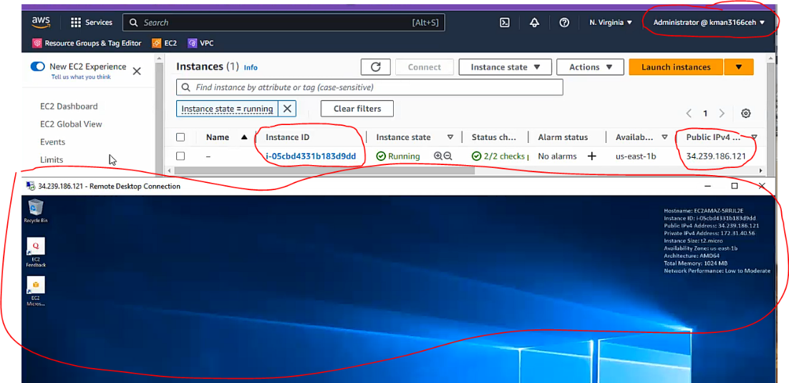

**Clean-up**

1. Once you have your 3 screenshots, terminate your instance either from the Management console or the CLI using the command **aws ec2 terminate-instances --instance-ids *yourinstanceID*** (you can get this from the Management Console InstanceID column).
2. Delete your newly created user you created earlier.
3. Save and upload your Word Doc to Bb.